Segmentation and Clustering of NY City and Toronto

**A comparison of Neighborhoods**

Nikhila Anumukonda

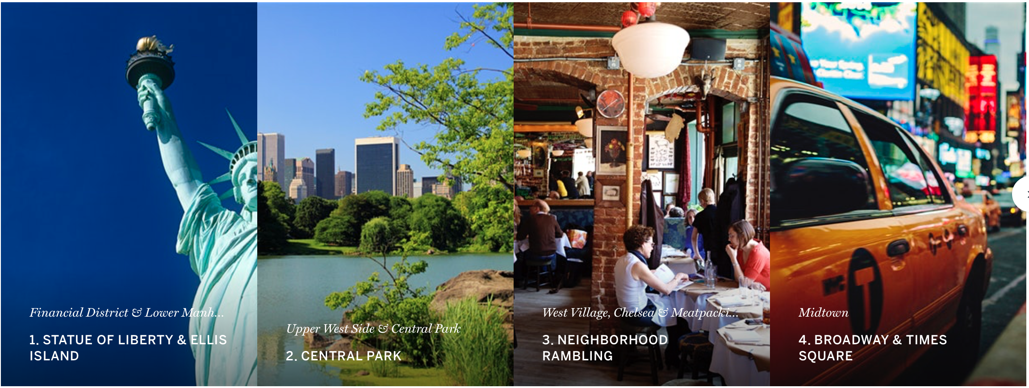

NEW YORK

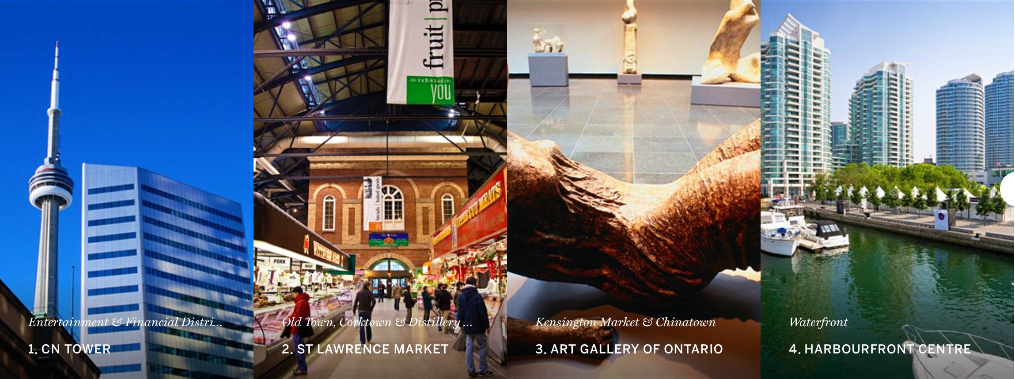

TORONTO

# Data Acquisition and Preparation

In this section, we will discuss the process of data acquisition and preparation of the data for our analysis. There re basically two types of data we will extract and process. The neighbourhood data for New York and Toronto and the Venue data for them.

The Neighbourhood data is extracted from data sources provided by IBM and the Wiki page on the internet. It is then merged with the Geospacial data to get Longitudes and Latitudes of the neighourhoods.

The Venue data is retrieved from Foursquare API which is one of the largest sources of location and venue data.

## Neighborhood and Venue Data for Toronto

Neighborhood

For Toronto data, there is a Wikipedia page titled “List of postal codes of Canada: M”. This page lists the postal codes in Canada that start with the letter M which are the postal codes of Toronto city; it lists the postal codes with the neighborhood and borough name associated with each postal code.

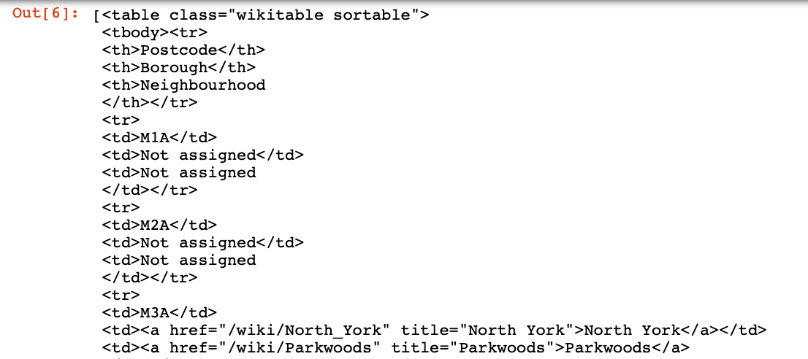

To download this webpage and extract the relevant data from it,the BeautifulSoup function was used. The resulting dataset has 103 neighbourhoods.

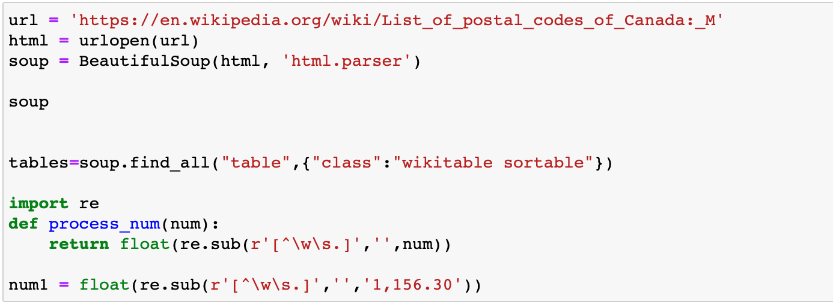Figure 1 Code to scrape data from the wiki page

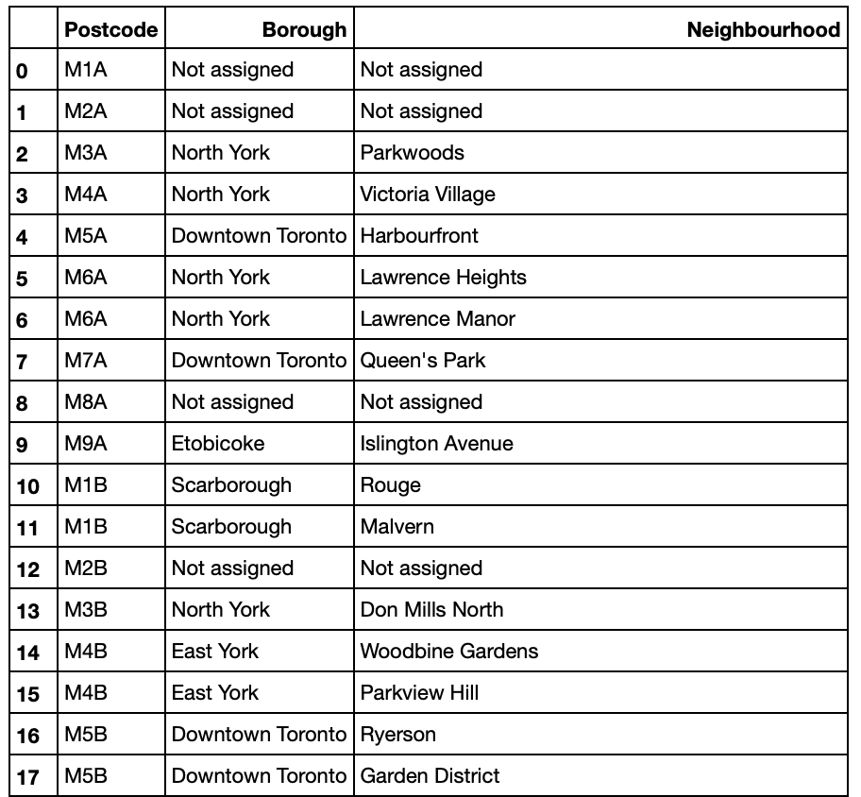

Fig 2 : List of neighborhoods for Toronto

Figure 2: Toronto’s postal codes with neighborhood and borough names

The data has Postcode, Borough and neighborhood information. The above table shows part of the resultset. The total number of neighborhoods are 103. It is observed that there some data elements that need cleaning such as :

1. Borough “Not assigned”
2. Neighborhood “Not assigned”
3. Neighborhoods with same postcodes and boroughs
4. Merge the neighborhoods which have same Borough
5. Filter and fetch data related to Toronto as the Borough

The code and result sets are as given in the following paragraph.

* **Borough “Not assigned”**

From Fig 2, we can see that Post codes M1A and M2A do not have a Borough assigned. Such data does not add value for our analysis. So, with the following code we will remove data with Borough “Not assigned” and the resulting dataset will be as in Fig 3.

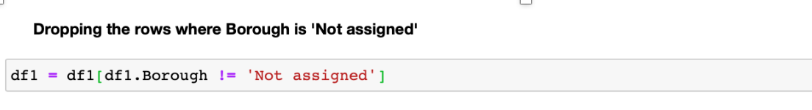

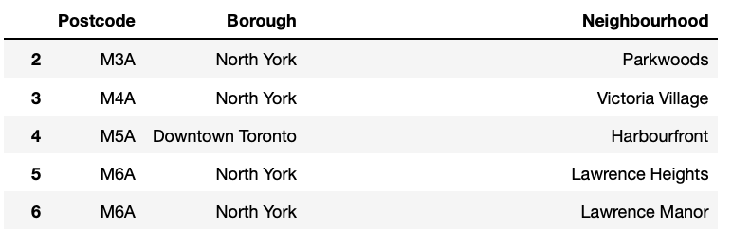

Fig 3 : Data without Borough “Not assigned”

* **Neighborhood “Not Assigned”**

Some of the neighborhoods have value “Not assigned”. Next step is to replace the name of the neighbourhoods which are 'Not assigned' with names of Borough. In Fig 4A, M7A, Queen’s Park neighborhood is “Not assigned” on the left, with the code snippet of Fig 4B, we replace the neighborhood name with the Borough name as shown on the right.

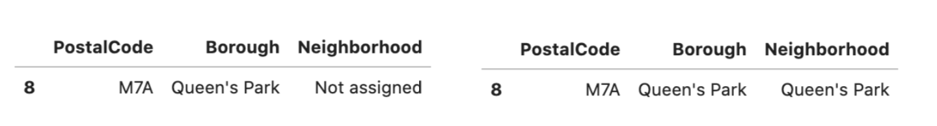

Fig 4A : result of replacing “Not assigned” neighborhood with borough name

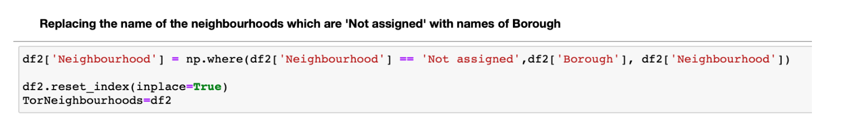

Fig 4 B: Code snippet for replacing the name of the neighbourhoods which are 'Not assigned' with names of Borough.

* **Neighborhoods with same postcodes and boroughs**

M5B has same boroughs but different neighborhoods. We combine the neighborhoods with same postcodes. M6A has two neighborhoods “Lawrence Heights” and Lawrence Manor” as shown in Fig 5.

These two neighborhoods are combined and updated into the Neighborhood column.The resulting row will be as given in the Fig 7.

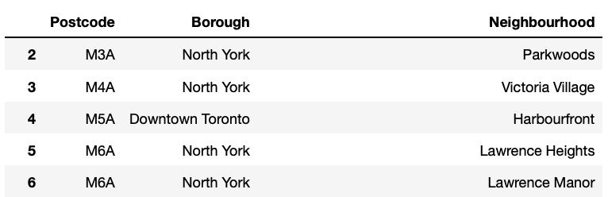

Fig 5 : neighborhoods with same postcodes

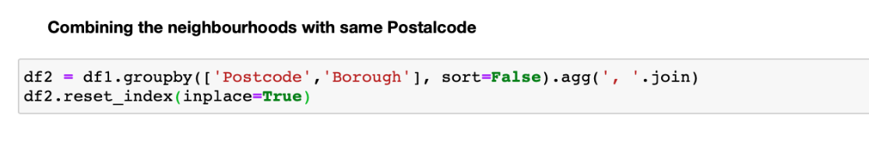

Fig 6 : Code snippet to combine neighborhoods with same postcodes

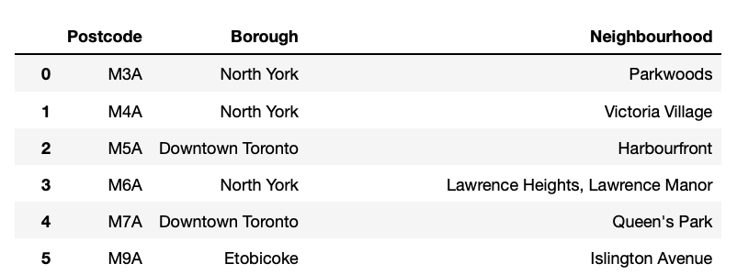

Fig 7 : Merging neighborhoods with same postcodes and boroughs

* **Merge the neighborhoods which have same Borough.**

There are neighborhoods with same Borough like the one given in Fig 8.

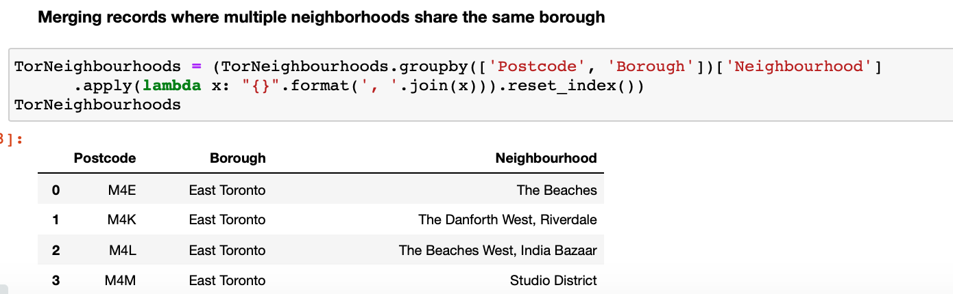

Fig 8 : Merged neighborhoods with same Borough

* **Filter and fetch data related to Toronto as the Borough**

In the next step, we filter the dataset to represent Toronto boroughs only.The result will be as show in Fig 10.There are 4 boroughs and 39 neighborhoods.

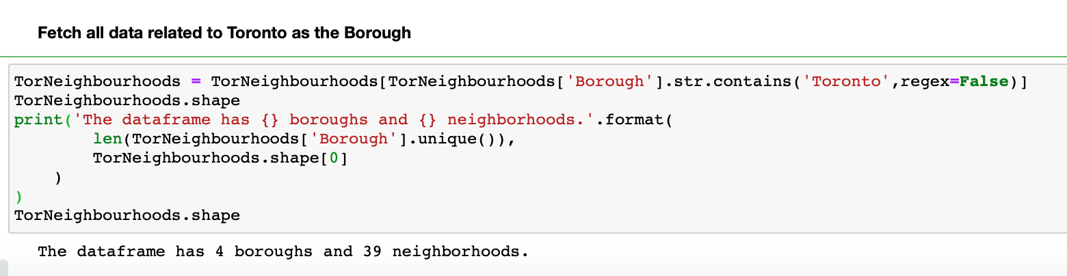

Fig 9 : Code snippet to filter Toronto Borough

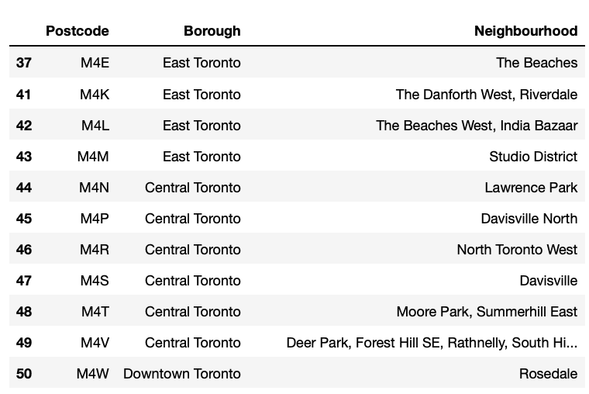

Fig 10 : Dataset with Toronto Boroughs only

Now, We require the Longitudes and Latitudes for each of the neighbourhoods. We read from the CSV file provided for IBM and merge the data with the TorNeighbourhoods dataset to get both neighbourhood data along with the coordinate data.

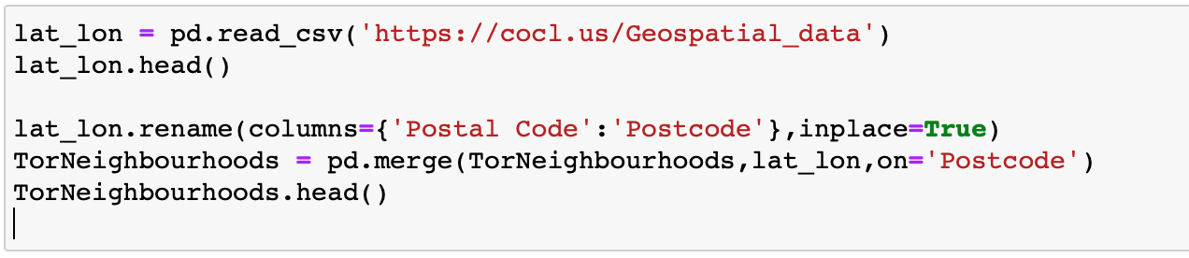

Fig 11 : Code to fetch Longitude and latitude data

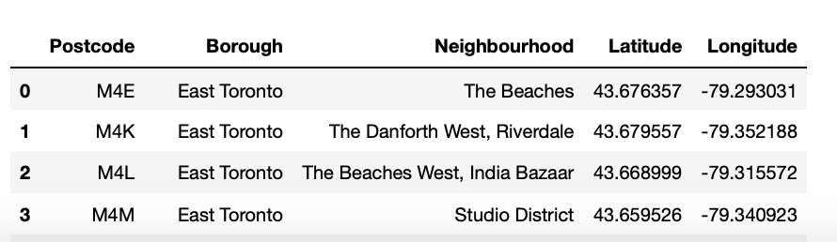

Fig 12 : Resulting dataset with Longitude and Latitude

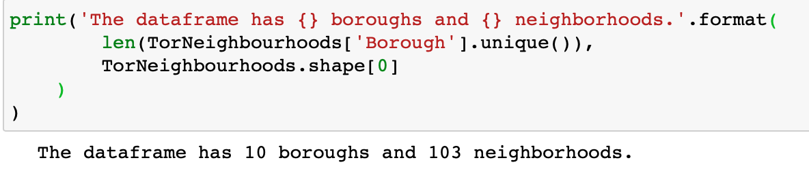

Fig 13: The dataset has 10 boroughs and 103 neighbourhoods

In the next step, we build the map of all Toronto neighbourhoods. For this , we fetch the longitude and latitude of Toronto and use Folium to draw the map.

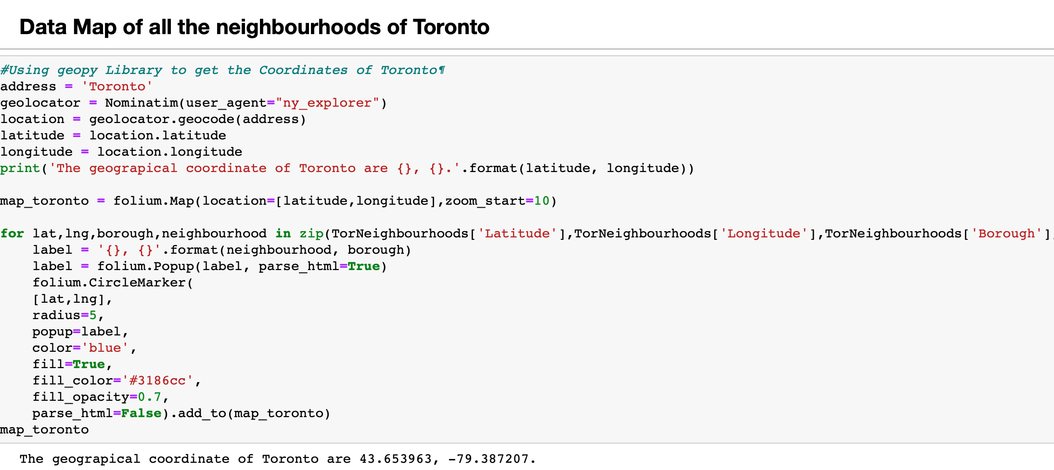

Fig 14 : code to Map neighborhoods

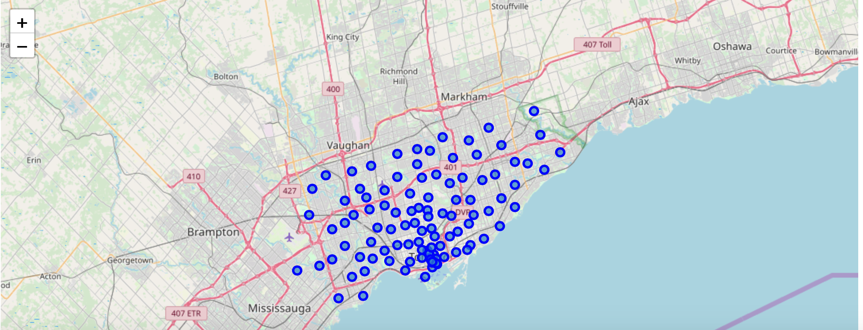

Fig16 : Resulting Map of Toronto Neighbourhoods

**Venue data**

Now, we will retrieve all the Venue data for Toronto neighbourhoods. We exclude the venues such as Building,Office,Bustop etc. Using the function getNearbyVenues, we will fetch the Venue categories for each neighbourhood.Here, we use the Foursquare API to fetch the venues Foursquare which is a popular source of location and venue data. Foursquare API service will be utilized to access and download venues data.

To retrieve data from Foursquare using their API, a URL should be prepared and used to re- quest data related a specific location. An example URL is the following:

https://api.foursquare.com/v2/venues/search?

&client_id=1234&client_secret=1234&v=20180605&

ll=40.89470517661,-73.84720052054902&radius=500&limit=100

where search indicates the API endpoint used, client_id and client_secret are credentials used to access the API service and are obtained when registering a Foursquare developer account, v indicates the API version to use, ll indicates the latitude and longitude of the desired location, radius is the maximum distance in meters between the specified location and the retrieved venues, and limit is used to limit the number of returned results if necessary.

Figure 17 shows the code used to create a function that takes as input the names, latitudes, and longitudes of the neighborhoods, and returns a dataframe with information about each neighbor- hood and its venues.

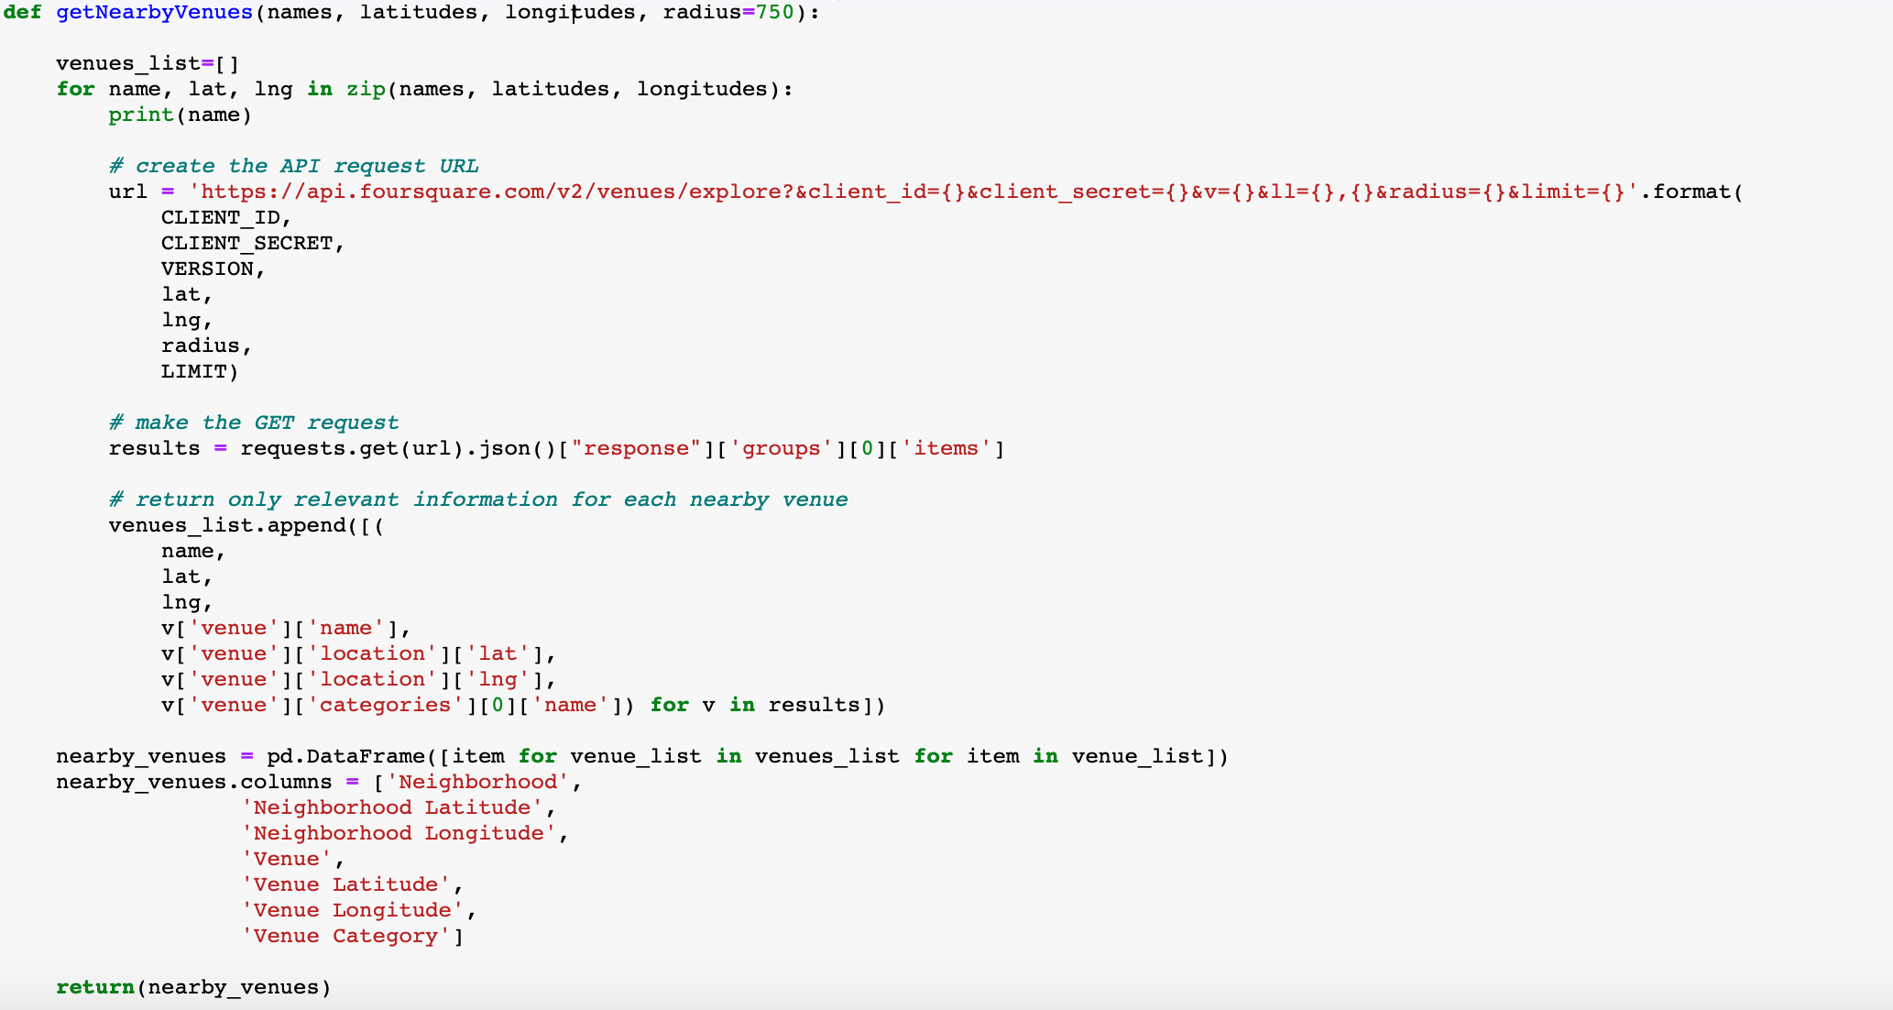

Fig 17 : getNearbyVenues function using Foursquare API.

The resulting Data frame lists the venue, Venue category, Venue latitude and longitudes as given in Fig 18.

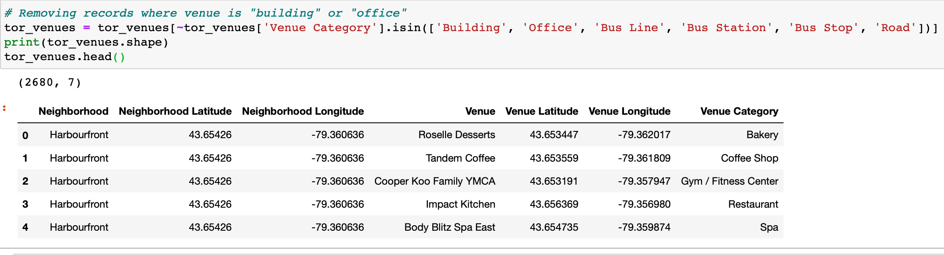

Fig 18 : Venue dataframe for Toronto

Grouping by the neighborhoods will fetch the number of venues in each neighbourhood. Each neighbourhood has different number of venues. For example : Adelaide King,Richmond has 99 neighbourhoods while Berczy park has 100 as shown in fig 22.

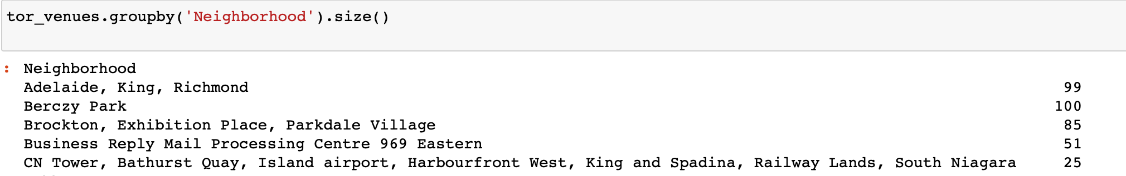

Fig 22 : Number of Venues in each neighbourhood

## Neighborhood and Venue data for New York City

**NY Neighbourhoods**

The neighborhood data for New York City was is provided by IBM at the following location <https://cocl.us/new_york_dataset>. The dataset is a JSON file that specifies the name of each neighborhood, its coordinates—latitude and longitude, its borough. Figure 23 shows the code used to process the JSON file and the resulting dataset with 306 neighbourhoods in Figure 24.The data is stored in a Pandas dataframe NYNeighborhoods

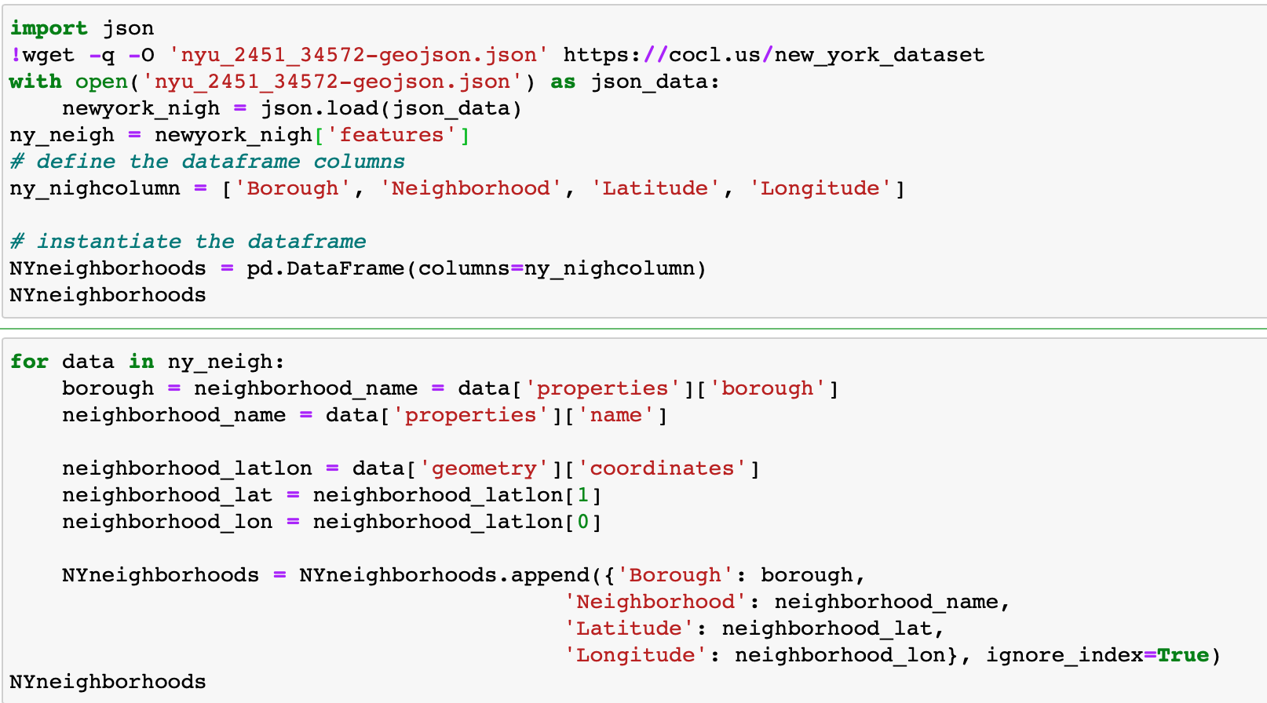

Fig 23 : importing data from Json file

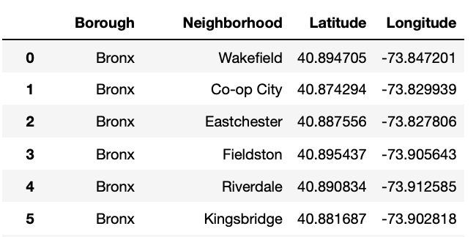

Fig 24 : Dataframe with Latitude and Longitude

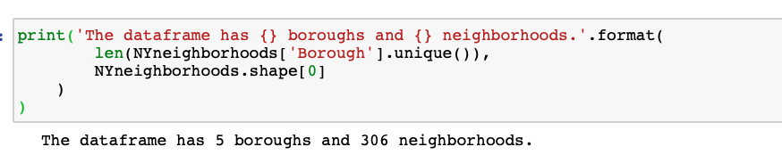

Fig 25: Number of Boroughs and Neighbourhoods

Further, there are neighborhoods that share the same name but are located in different boroughs. To deal with this case, we will include the borough name in the name of these neighborhoods.

"Bay Terrace" neighborhood which is located in "Staten Island" borough will be named "Bay Terrace, Staten Island" and the one in "Queens" will be named "Bay Terrace, Queens" as shown in Fig 26

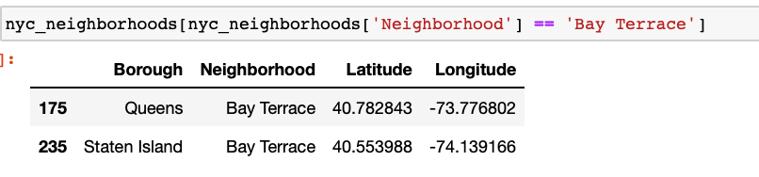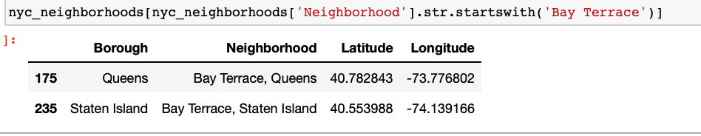

Fig 26 : Neighborhoods that share the same name but are located in different boroughs

The below code solves this issue.

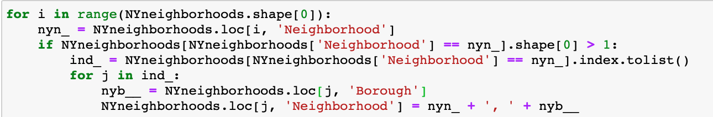

Fig 27 : Code to include borough name in the name of neighbourhoods which share same name but located in different boroughs.

With the help of Folium, we draw the map of New York with all the neighbourhoods.

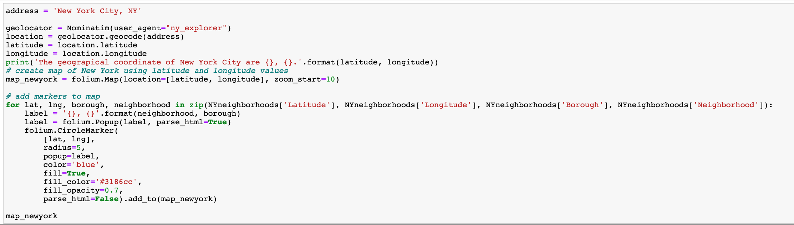

Fig 29 : Code for Data Map for New York neighbourhoods

Having data of the coordinates of NYC neighborhoods, it is possible to draw a map using Folium Python package of NYC and its neighborhoods. Figure 5 shows this map; each blue circle represents the location of one neighborhood.

Figure 30 : A map of NYC and its neighborhoods

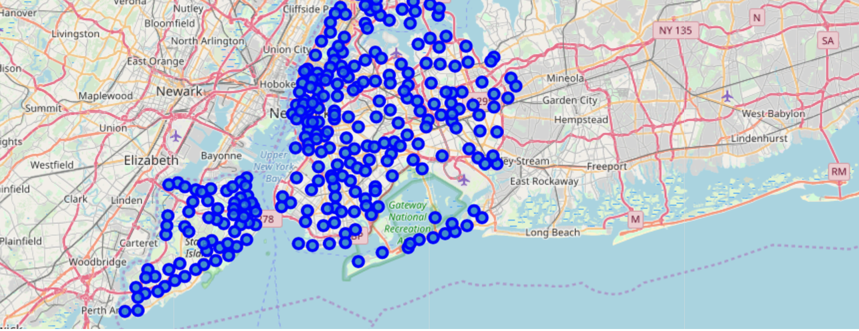

**NY Venues**

For each city, data that describes the venues of its neighborhoods and the categories of these venues is needed. Venues data will be retrieved from Foursquare which is a popular source of location and venue data. Foursquare API service will be utilized to access and download venues data.

To retrieve data from Foursquare using their API, a URL should be prepared and used to re- quest data related a specific location. An example URL is the following:

https://api.foursquare.com/v2/venues/search?

&client_id=1234&client_secret=1234&v=20180605&

ll=40.89470517661,-73.84720052054902&radius=500&limit=100

where search indicates the API endpoint used, client_id and client_secret are credentials used to access the API service and are obtained when registering a Foursquare developer account, v indicates the API version to use, ll indicates the latitude and longitude of the desired location, radius is the maximum distance in meters between the specified location and the retrieved venues, and limit is used to limit the number of returned results if necessary.

Figure 12 shows the code used to create a function that takes as input the names, latitudes, and longitudes of the neighborhoods, and returns a dataframe with information about each neighbor- hood and its venues. It creates an API URL for each neighborhood and retrieves data about the venues of that neighborhoods from Foursquare.

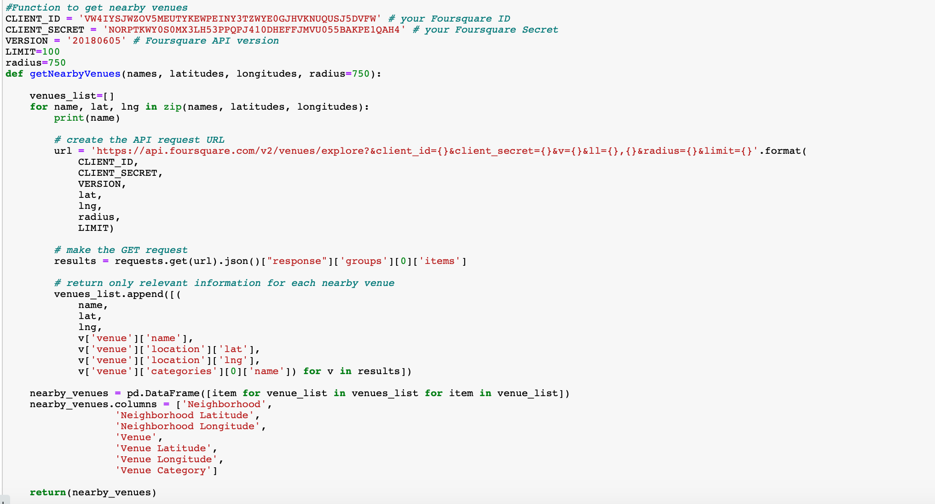

Figure 31 : Code used to build a venues dataframe for a city neighborhoods

This function “getNearbyVenues” in Fig 31 retrieves information about venues in each neighborhood.It takes as input a list of the names of the neighborhoods, a list of their latitudes, and a list of their longitudes.It returns a dataframe with information about each neighborhood and its venues.

After retrieving the venue data, venues whose category is “Building”, “Office”, “Bus Line”, “Bus Station”, “Bus Stop”, or “Road” were excluded because they are not expected to add analytical value in this project.



Fig 32

Using this function with NYC neighborhood data retrieved data about more than 2,33,375 venues in NYC neighborhoods. For each venue, venue name, category, latitude, and lon- gitude were retrieved. The head of the dataframe returned by the function for NYC is shown in Figure 33. We can see that each row in the dataframe contains data about one venue: the venue name, coordinates (latitude and longitude), and category in addition to the neighborhood in which the venue is located and the coordinates of the neighborhood.

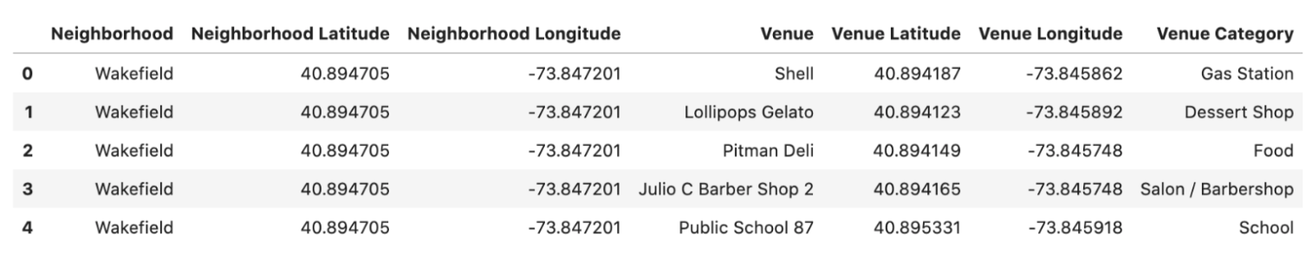

Fig 33 NY dataframe with venue details

Different numbers of venues were found in different neighborhoods: for example, data about 81 venues were returned for Allerton neighborhood, 77 venues for Annadale neighborhood, and 71 venues for Arlington neighborhood as shown in Fig 25.

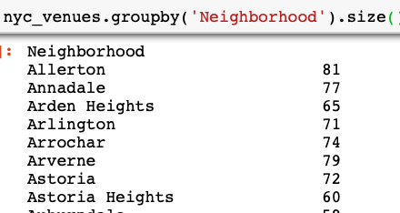

Fig 34 : Number of venues in each neighbourhood

Each venue of them belongs to one of 574 unique categories.

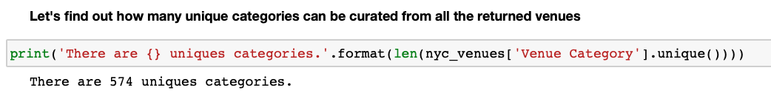

Fig 35 : Unique venue categories